**UNIT-2**

|  |
| --- |
| **IoT and M2M Communication M2M**  Introduction, M2M, Difference between IoT and M2M, SDN & NFV for IoT.  **IoT Platform Design Methodology**  Introduction, IoT Design Methodology, Case Study: Weather Monitoring. |

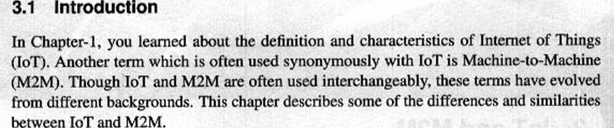

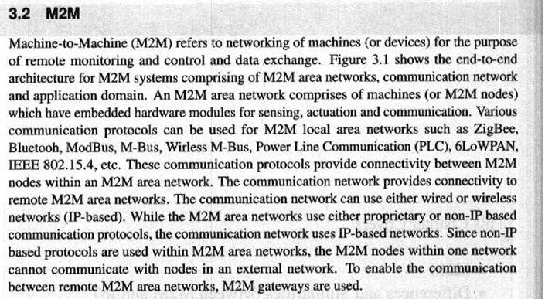

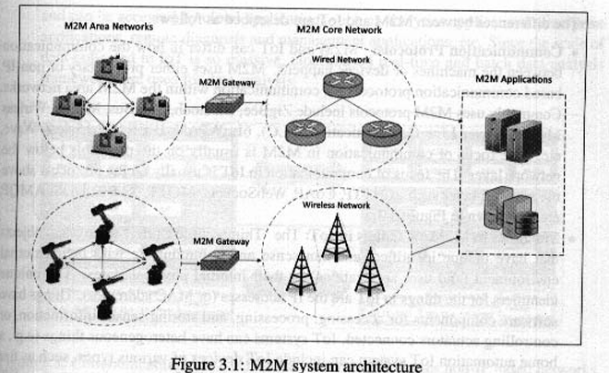

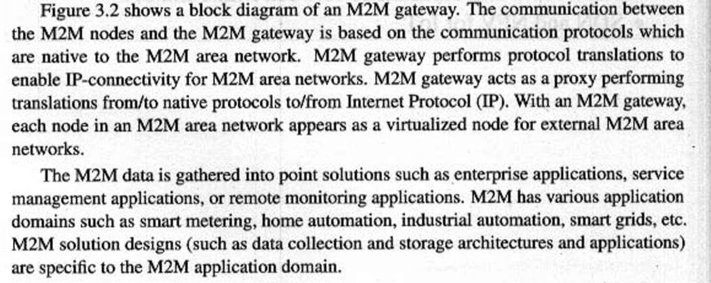

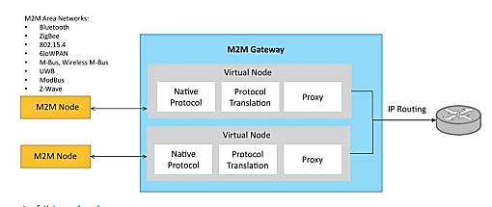

**DIFFERENCE BETWEEN M2M AND IOT**

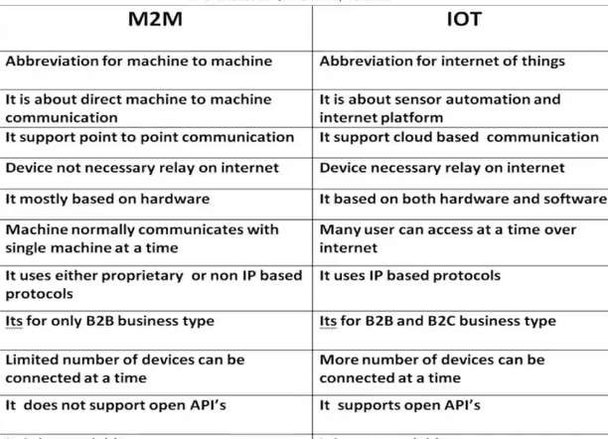

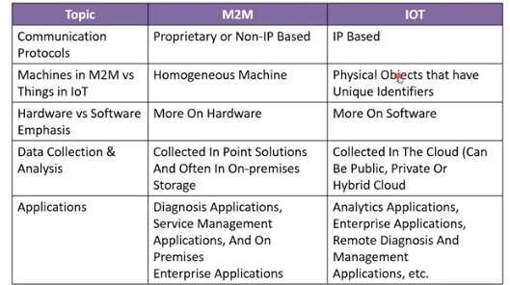

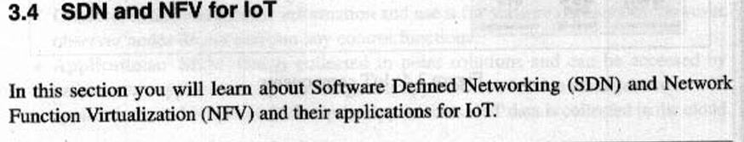

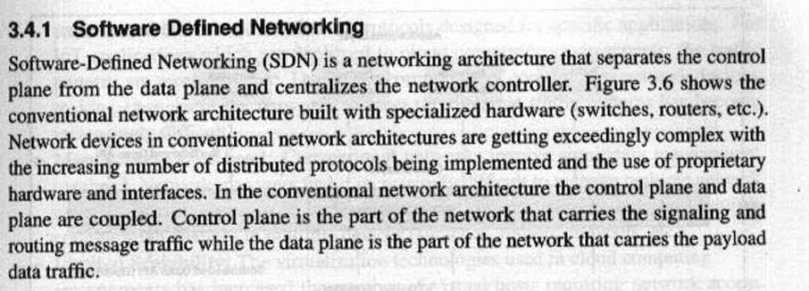

* Network devices in conventional n/w architectures are getting exceedingly complex with the increasing number of distributed protocols being implemented and the use of proprietary h/w and interfaces.

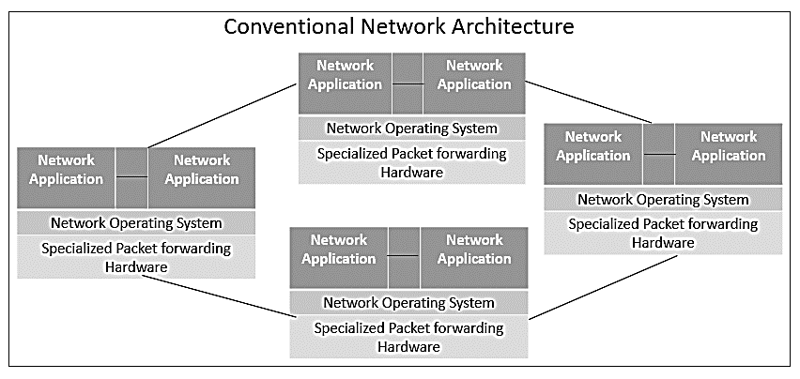

**Software Defined Networking – SDN**

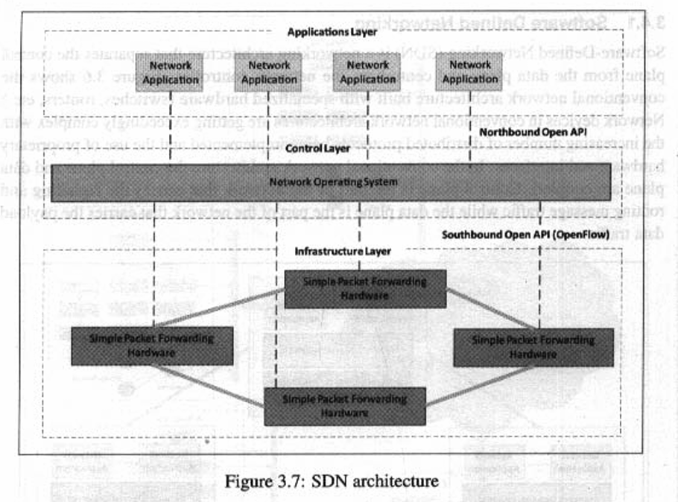

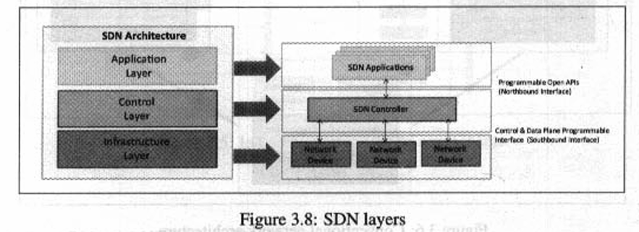

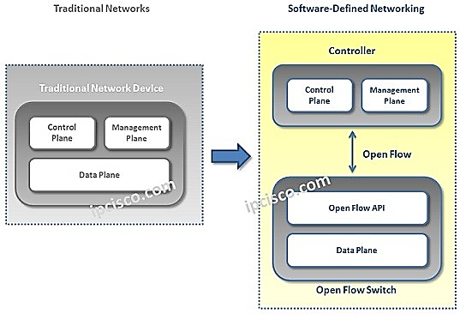

* SDN is a networking architecture that separates the control plane from the Data plane and centralizes the network controller.
* SDN Simplifies data communication in N/W.
* SDN maintains a unified view of the configuration, Management and provisioning simpler.
* Architecture which aims to improve overall network performance and make networks agile and flexible by enabling a dynamic and programmatically efficient network configuration.
* SDN is a technology that separates control plane management of network devices from underlying data plane that forwards network traffic in order to enable more automated provisioning and policy-based management of network resources.
* **SDN Application:** Relay requests or networks through SDN controller using API.
* **SDN Controller:** Collects network information from hardware and sends this information to applications.
* **SDN Networking Device:** Helps in forwarding and data processing tasks.

**Limitation of CSDN**

* Complex Network Device.
* Management overhead.
* Limited scalability.

**SDN Architecture**

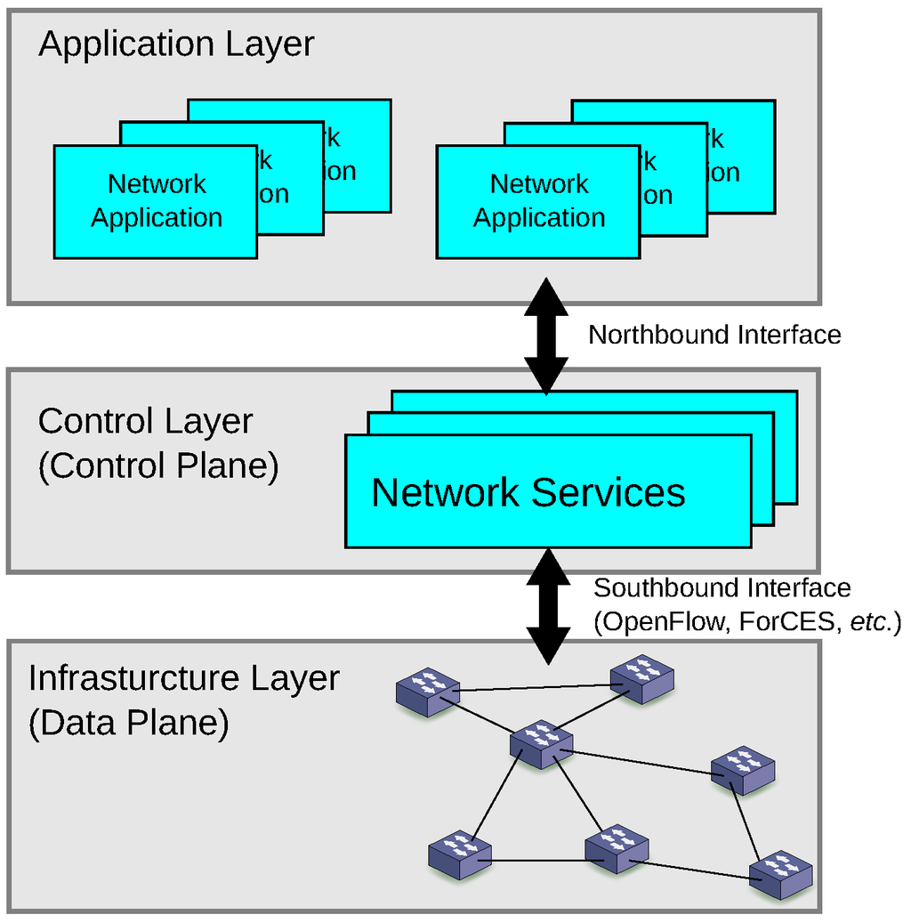

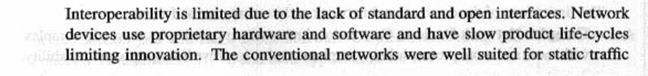

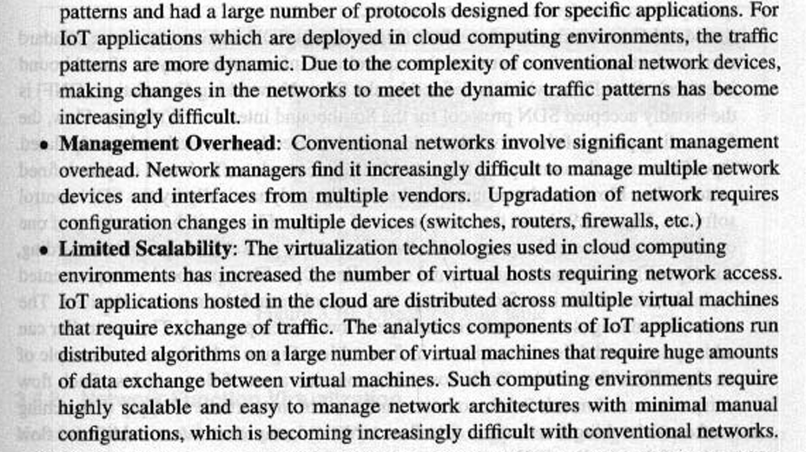

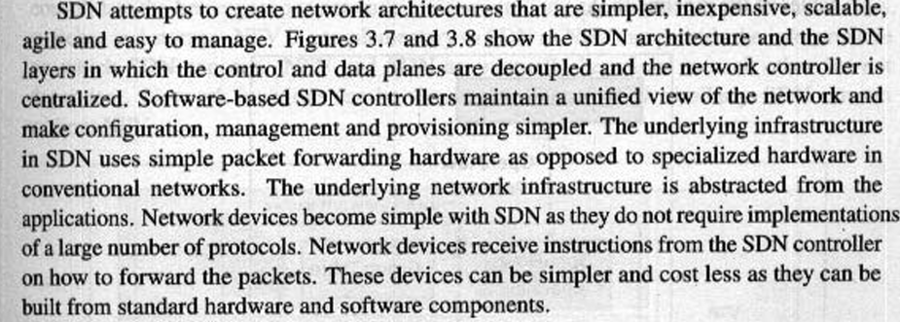

**Key Elements of SDN**

* Centralized Network Controller
* Programmable Open APIs
* Standard Communication Interface (OpenFlow)
  + Defined by Open Networking Foundation (ONF).
  + Broadly accepted protocol for southbound interface.
  + With OF, the forwarding plane of the n/w devices can be directly accessed and manipulated.
  + Uses the concept of flows.
  + Flows can be programmed.
  + OpenFlow protocol is implemented on both sides of the interface b/w the controller and the network devices.
  + Controller manages the OF switch via OF protocol.
  + Controller can add, update and delete flow entries in flow table.

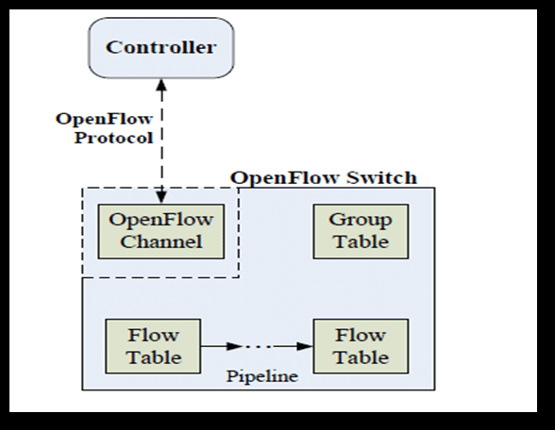

**Example of OpenFlow flow Table**

* Each flow table contains a set of flow entries.
* Each flow entry consists of match fields, counters and set of instructions to apply matching packets.
* Matching starts at the first flow table and may continue to additional flow tables of the pipeline.

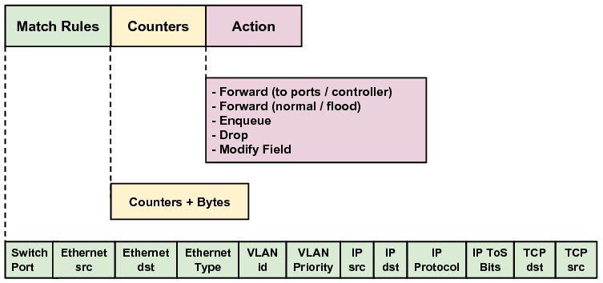

Advantages:

Centralized Controller

Faster scaling & Deployment

Lower Hardware cost

Disadvantages:

Increased Complexity

Single point of failure.

Lesser Traditional Networking jobs.

**Network Functions Virtualization NFV**

* Technology that leverages virtualization to consolidate the heterogeneous network devices onto Industry standard high-volume servers, switches and storage.
* Complimentary to SDN and provides infrastructure on which SDN can run.
* Mutually beneficial to each other, but not dependent.
* NFV comprises of Network functions implemented in s/w that run on virtualized resources in the cloud.
* NFV enables separation of n/w functions which are implemented in s/w from the underlying h/w.
* VNF reduces the equipment costs and also reduces power consumption.
* NFV is applicable only to data plane and control plane functions in fixed and mobile networks.
* Standardized by European Telecommunication Standards Institute (ETSI).
* Key elements of NFV architecture are
  + **Virtualized Network Function:** S/w implementation of a n/w function which is capable of running over the NFV Infrastructure (NFVI). Eg: VFirewall, VRouter etc.
  + **NFVI:** Includes Computer, n/w and storage resources that are visualized.
  + **NFV Management & Orchestration:** Focuses on all virtualization-specific management tasks and covers the orchestration and life cycle management of physical and s/w resources that support the infrastructure virtualization and life cycle management of VNF’s

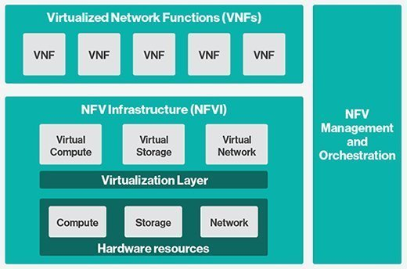



**UNIT-4**

Basic Building blocks - Boards - Raspberry Pi, Arduino, Tiva.Working with Sensors and Actuators

